AIML Project Data Visualization
Title of the Project:
City Savior: AI-ML Disaster Risk Prediction & Early Alert System
import libraries

Name: Siril punna
Roll no: 2420030300

Imports:
import pandas as pd
import matplotlib.pyplot as plt
import seaborn as sns

Data clean and preprocess it

- Load Dataset
Upload your Excel file in Colab (from left panel or via files.upload())
file_path = "/content/dataset.xlsx" # Change filename if different
df = pd.read_excel(file_path, sheet_name="EM-DAT Data")

- Data Cleaning
Drop rows without year information
df = df.dropna(subset=["Start Year"])

- Convert year to integer
df["Start Year"] = df["Start Year"].astype(int)

1. Line Chart - Disasters per Year
Code:
yearly_counts = df.groupby("Start Year").size()
plt.figure(figsize=(12,6))
plt.plot(yearly_counts.index, yearly_counts.values, marker="o", color="b")
plt.title("Number of Disasters per Year")
plt.xlabel("Year")
plt.ylabel("Number of Disasters")
plt.grid(True)
plt.show()
Data Visualization:
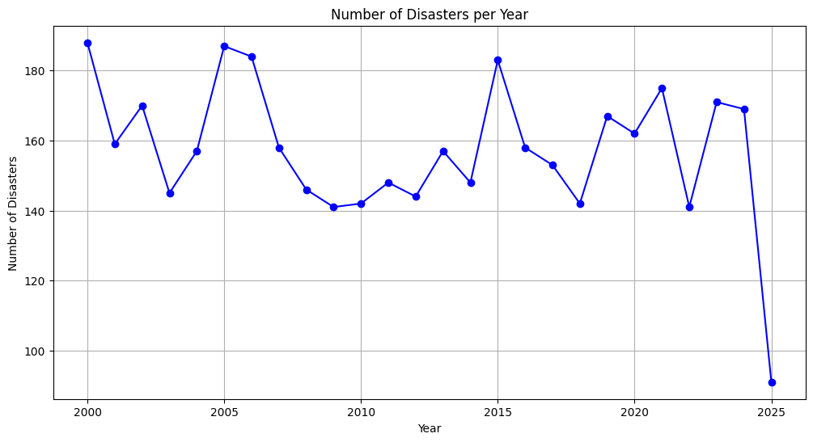

Report:
1. Disasters per Year (Line Chart)
The line chart indicates a general upward trend in the number of disasters reported over the years. While some fluctuations exist, the long-term pattern suggests that natural disasters are being recorded more frequently. This increase may reflect both actual climate-related intensification and improved global reporting mechanisms.

2. Bar Graph - Top 10 Countries

Code:
top_countries = df["Country"].value_counts().head(10)
plt.figure(figsize=(12,6))
sns.barplot(x=top_countries.values, y=top_countries.index, palette="viridis")
plt.title("Top 10 Countries by Disaster Occurrence")
plt.xlabel("Number of Disasters")
plt.ylabel("Country")
plt.show()

Data Visualization:
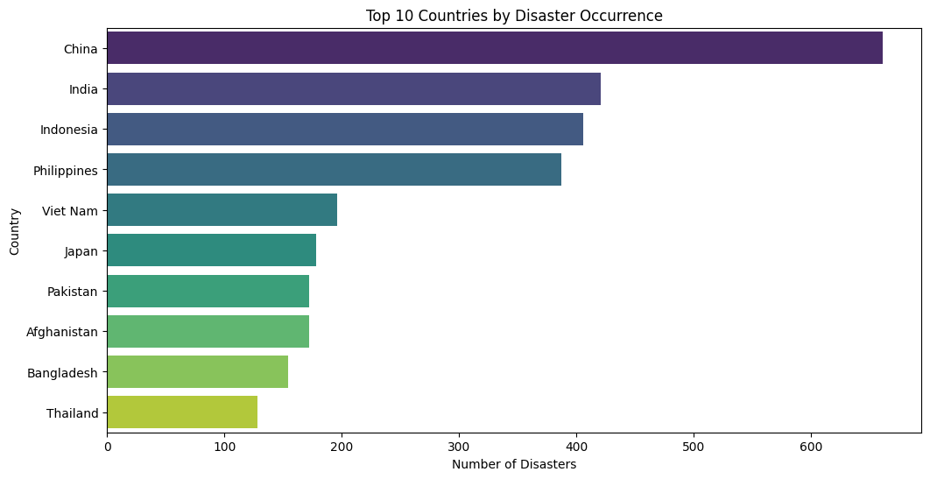

Report:
2. Top Affected Countries (Bar Graph)
The bar graph highlights that certain countries—particularly those in Asia and Africa—experience the highest number of disasters. Nations such as India, Bangladesh, China, and the USA are consistently among the most affected. This pattern reflects both geographical vulnerability (e.g., monsoons, earthquakes, storms) and large population exposure.

3. Pie Chart - Distribution of Disaster Types

Code:
disaster_types = df["Disaster Type"].value_counts()
plt.figure(figsize=(8,8))
plt.pie(disaster_types.values, labels=disaster_types.index, autopct="%1.1f%%", startangle=140)
plt.title("Distribution of Disaster Types")
plt.show()

Data Visualization:
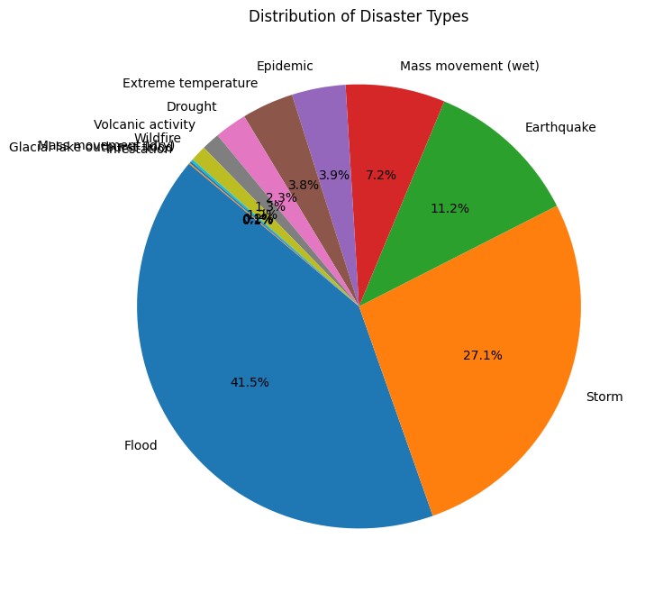

Report:

3. Disaster Type Distribution (Pie Chart)
The pie chart shows that Floods and Storms account for the largest share of disasters, followed by Earthquakes and Droughts. This indicates that hydro-meteorological hazards dominate global disaster occurrences, reinforcing the importance of climate resilience and disaster preparedness.

4. Heatmap - Disaster Frequency (Year vs. Type)

Code:
heatmap_data = df.pivot_table(index="Start Year", columns="Disaster Type",
values="DisNo.", aggfunc="count", fill_value=0)
plt.figure(figsize=(14,8))
sns.heatmap(heatmap_data, cmap="YlOrRd", linewidths=0.5)
plt.title("Heatmap of Disaster Frequency by Year and Type")
plt.show()

Data Visualization:
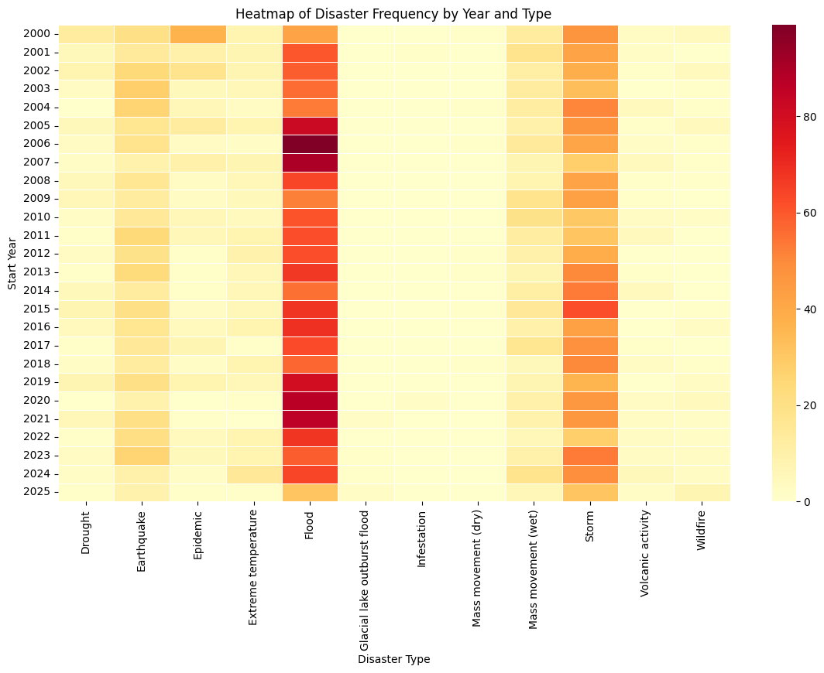

Report:

4. Heatmap of Disaster Frequency (Year vs. Type)
The heatmap reveals periods where specific types of disasters spike. For example:
- Storms and floods intensify in clusters, often linked to climate cycles like El Niño/La Niña.
- Earthquakes, while less frequent, show consistent occurrence across decades.
This suggests that different disaster types have distinct temporal patterns that require tailored preparedness strategies.

5. Histogram - Total Deaths

Code:

plt.figure(figsize=(10,6))
sns.histplot(df["Total Deaths"].dropna(), bins=50, kde=True, color="red")
plt.title("Distribution of Total Deaths in Disasters")
plt.xlabel("Total Deaths")
plt.ylabel("Frequency")
plt.show()

Data Visualization:
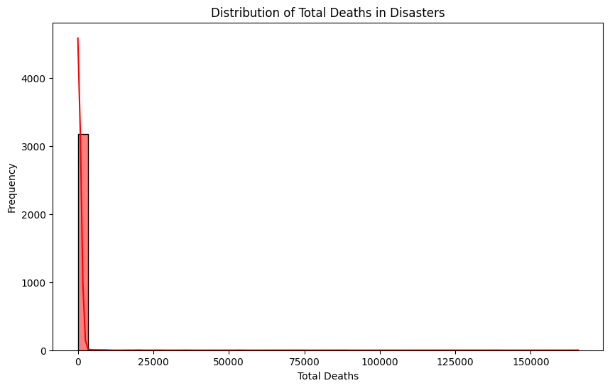

Report:

5. Distribution of Total Deaths (Histogram)
The histogram indicates that while most disasters cause relatively few deaths, a small number of catastrophic events result in extremely high fatalities (e.g., earthquakes, tsunamis, and major cyclones). This distribution follows a long-tail pattern, where rare but severe disasters account for the majority of casualties.

Key Insights
- Rising Disaster Frequency – More disasters are being recorded over time.
- Regional Concentration – South Asia, East Asia, and North America are highly affected.
- Dominance of Climate-Related Hazards – Floods and storms form the bulk of global disasters.
- Catastrophic Outliers – Most events are moderate, but a few extreme disasters cause massive loss of life and damage.
- Policy Implication – Countries need climate adaptation strategies, better early-warning systems, and resilient infrastructure to reduce disaster impacts.

